Network File System/Sharing

**What is NFS?**

* Network file sharing (NFS) is a protocol used for sharing files and directories between computers on a network.
* NFS is useful when there is a need to quickly share a large number of files across many devices.

**Setting up NFS server:**

**Server Side**

**Install required packages**

#yum install nfs-utils in both side server and client

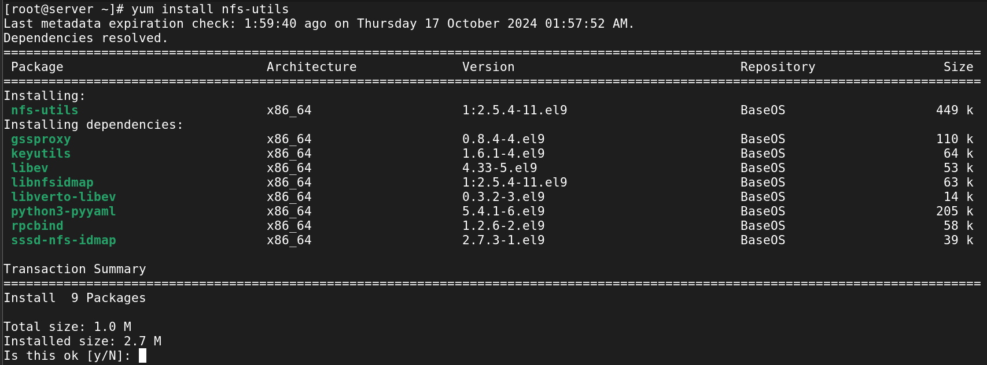

**Create a directory to be exported**

#mkdir /datas

Create files or cp files for exporting

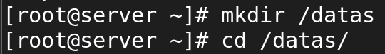

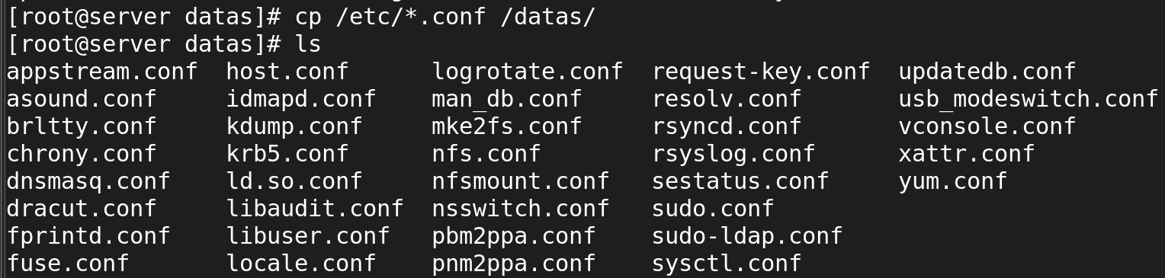

Modify /etc/exports to export the directory

/path/of/file <client ip address>(permission)





Start and enable the nfs-server.service

And we should restart service

# systemctl restart nfs-server.service



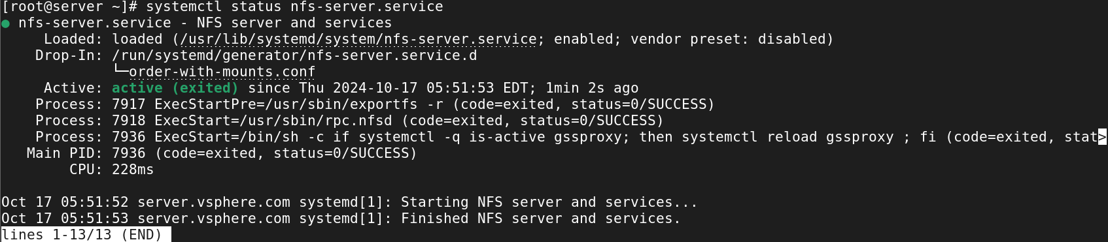

To check the files/directory currently being exported by an NFS server

#showmount -e localhost

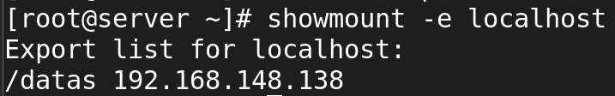

**CLIENT SIDE**

**Install required packages**

#yum install nfs-utils



To check the files/directory currently being exported by an NFS server

#showmount -e 192.168.148.139

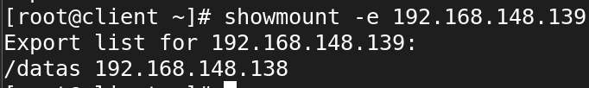

Create directory for mounting

#mkdir /data2

To check mount status

#df -Th

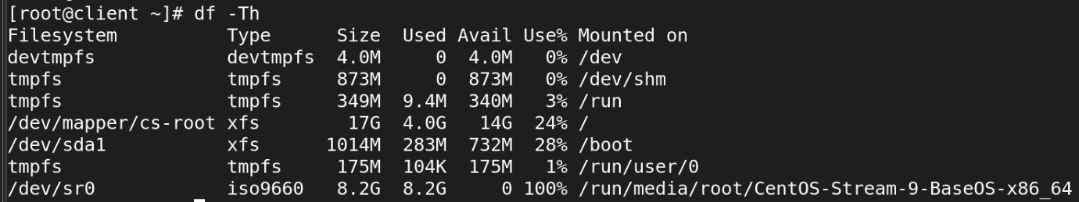

Mount the directory



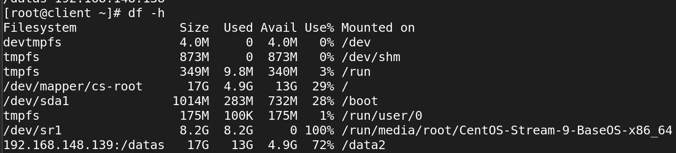

To make it permanent put entry in /etc/fstab file

#vi /etc/fstab

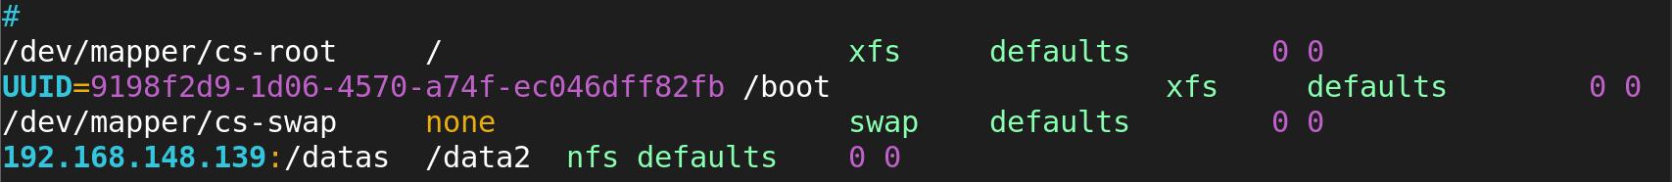

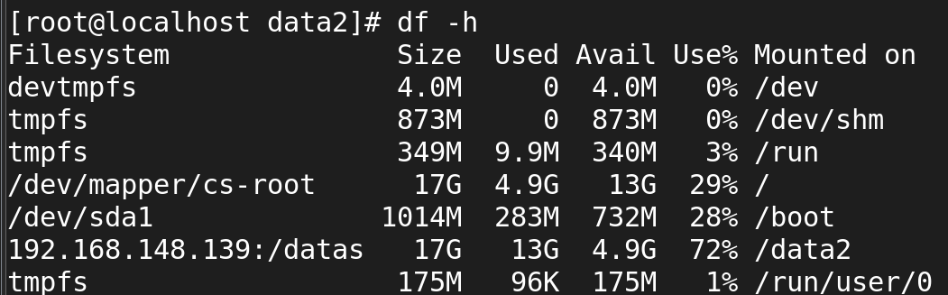

Try to create file inside the mounted directory

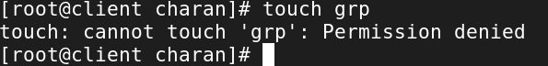

Now change the permission as 777 for /sathish in server

So that now you can create files inside the mounted directory

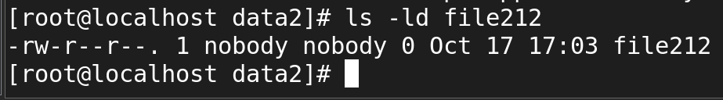

**Auto mount of an nfs share**

The main purpose of Autofs in an NFS (Network File System) server is to automatically mount and unmount network file systems or directories on demand. When a user or application tries to access a directory or file that is located on a remote NFS server, Autofs will automatically mount the file system only when it is accessed.if the server is down at the time when we boot the clint machine it will search in fstab entry at the time it toke too much of time.to resolving this problem we make auto mount.

**First step to remove an permanent mount in fstab**

**Next step to install packages.in client side**

**[root@localhost ~]# yum install autofs**

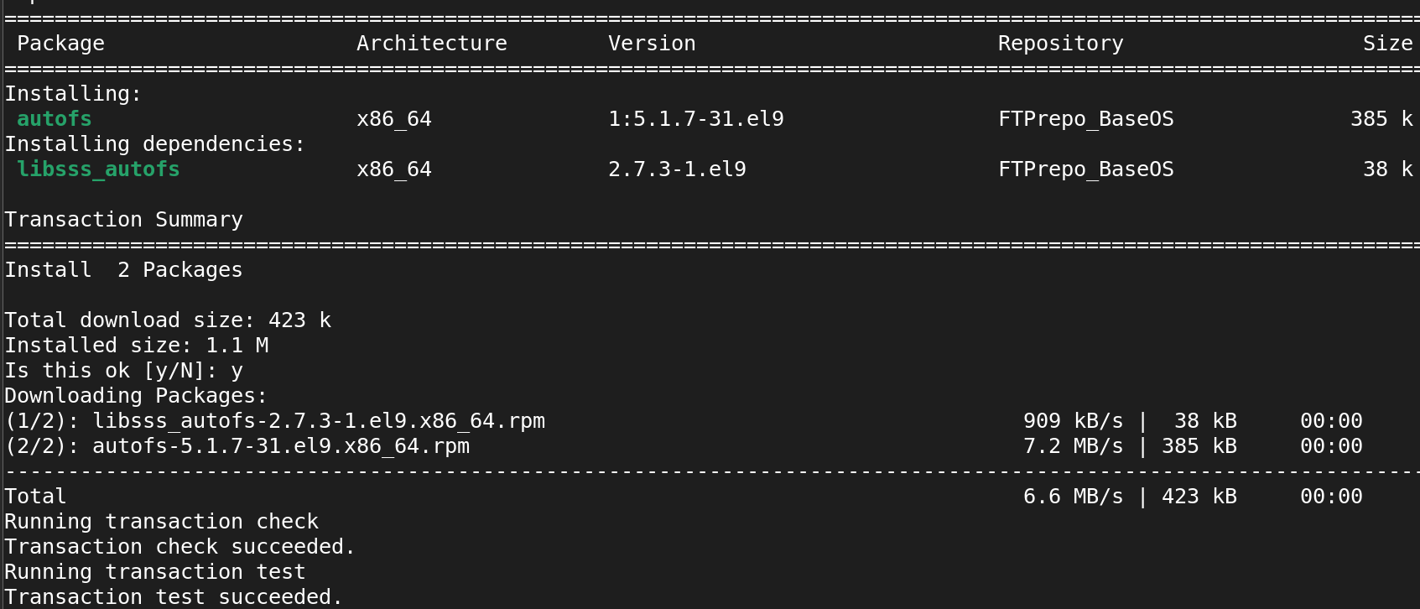

It is as same as nfs service in server side

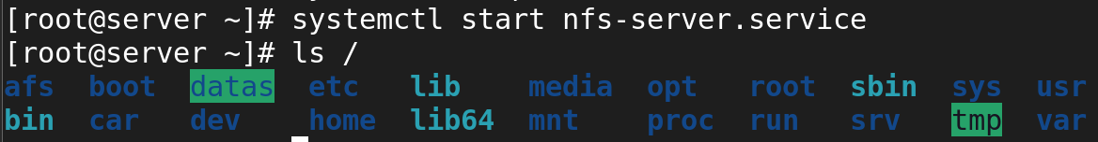

In the above the datas director was fully configed . now the datas directory we are going to automount in clint side .

Make dir data2 in clint side



### **Edit the Config file and add:**

**[root@localhost ~]# vi /etc/auto.master**

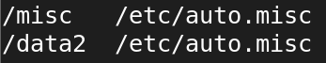

**[root@localhost ~]# vi /etc/auto.misc**

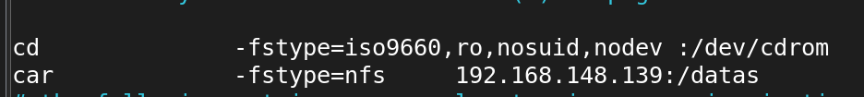

At normally it will not show the mounted dir

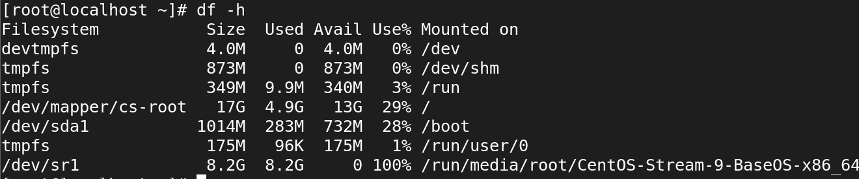

* Restart **autofs** Service:
* systemctl restart autofs



Now we can see the auto mount in car dir

It will on;y show in that particular dir we given

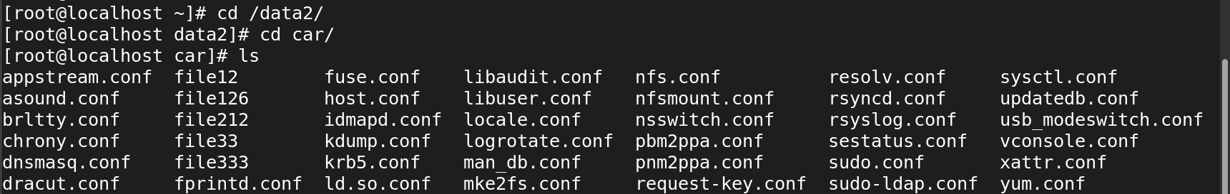

Mount df -h

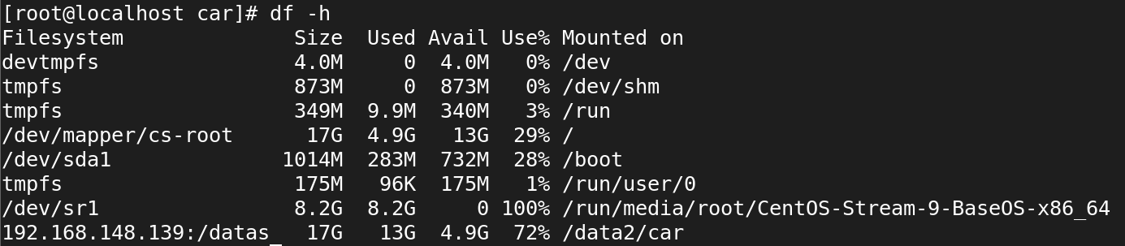

Now we can able to change the name of **vi /etc/auto.misc** instead of it we create our own name but it should be in **auto.**spvp for edit it we should config the **vi /etc/auto.master** file.



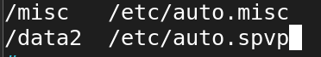



[root@localhost car]# vi /etc/auto.misc

Instead of we go and edit in the above file we want to edit the below file

[root@localhost car]# vi /etc/auto.spvp

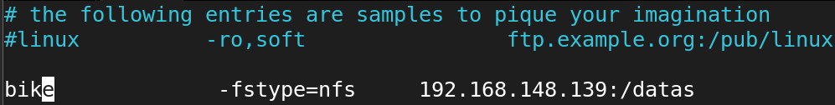



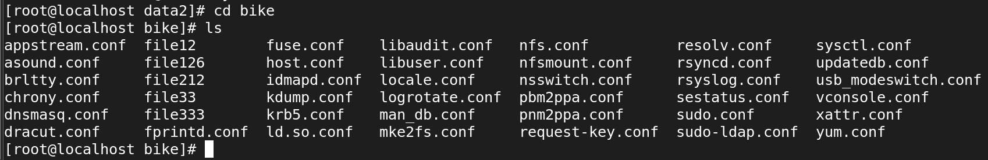

**Set an Automount Timeout**

### Edit the Config file and add:

### vi /etc/auto.master



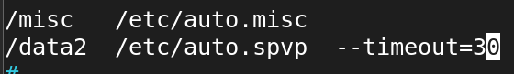

### Edit the /etc/auto.spvp:

### vi /etc/auto.spvp

### 

### 

* Restart **autofs** Service:
* systemctl restart autofs



Access the directory to see if it auto mounts

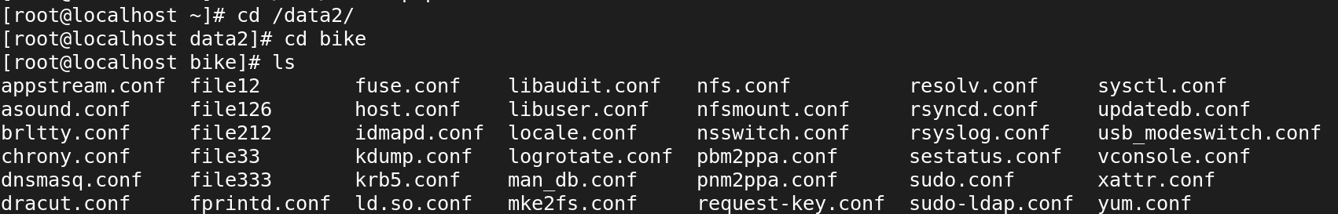

* Verify that the NFS share is auto mounted:

df -h

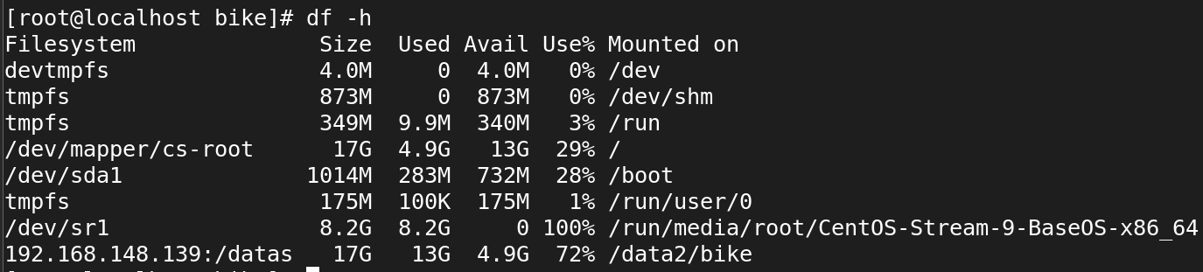

After the Timeout 30 seconds check the mount status it will not show

